Loop Coverage

Definition
# Source: AI Source: Provided by: [Data Path: Persons Table -> ID Column: 1, Name_En Column: Motasem Essam] -> From: [Chatgpt (GPT‑5 Mini)] on [8/24/2025]
Loop Coverage is a structural (white-box) testing technique that ensures all loops in the program are executed in all possible scenarios:
- Zero iterations – The loop body does not execute at all.
- Single iteration – The loop executes once.
- Multiple iterations – The loop executes more than once.
- The goal is to detect loop-related defects, such as incorrect loop boundaries, infinite loops, or off-by-one errors.

Key Characteristics
# Source: AI Source: Provided by: [Data Path: Persons Table -> ID Column: 1, Name_En Column: Motasem Essam] -> From: [Chatgpt (GPT‑5 Mini)] on [8/24/2025]
- Focuses specifically on loops in the code.
- Often applied in unit testing and integration testing, but also relevant in system-level structural testing.
- Can be used in for-loops, while-loops, and do-while loops.

Examples
# Source: AI Source: Provided by: [Data Path: Persons Table -> ID Column: 1, Name_En Column: Motasem Essam] -> From: [Chatgpt (GPT‑5 Mini)] on [8/24/2025]
- For-loop processing an array
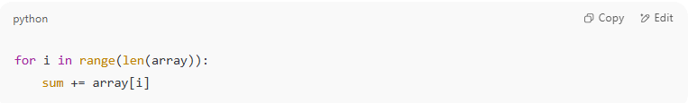
for i in range(len(array)):
sum += array[i]
  - Test empty array → zero iterations
  - Test array with 1 element → single iteration
  - Test array with multiple elements → multiple iterations
- While-loop
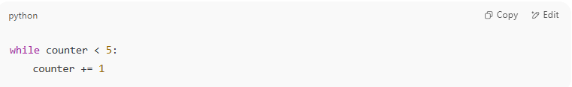
while counter < 5:
counter += 1
  - Test counter >= 5 initially → zero iterations
  - Test counter = 4 initially → single iteration
  - Test counter < 4 → multiple iterations

Advantages
# Source: AI Source: Provided by: [Data Path: Persons Table -> ID Column: 1, Name_En Column: Motasem Essam] -> From: [Chatgpt (GPT‑5 Mini)] on [8/24/2025]
✔ Detects boundary issues and logic errors in loops.
✔ Ensures all possible loop execution paths are tested.

Disadvantages
# Source: AI Source: Provided by: [Data Path: Persons Table -> ID Column: 1, Name_En Column: Motasem Essam] -> From: [Chatgpt (GPT‑5 Mini)] on [8/24/2025]
✘ Can be time-consuming for loops with many iterations.
✘ Complex nested loops may require many test cases.

Shortcut to Remember:
# Source: AI Source: Provided by: [Data Path: Persons Table -> ID Column: 1, Name_En Column: Motasem Essam] -> From: [Chatgpt (GPT‑5 Mini)] on [8/24/2025]
Loop Coverage = Test loops zero, once, and multiple times

